**Workpaper Reference:** 1549.A

**Source:** Clinical Data Repository Support BIA

**Provided by:** David Dessommes, Senior Manager, Application Dev

**Date:** 1/4/2022 and 1/6/2022

**Description:** The following screenshots show that there are four areas of impact evaluated in the CDR Business Impact Analysis (BIA) which evaluates business operations using a risk-based methodology.

**IA Notes:** IA noted that he CDR Business Continuity Plan which includes the CDR Business Impact Analysis (BIA) is now complete and approved by Management.

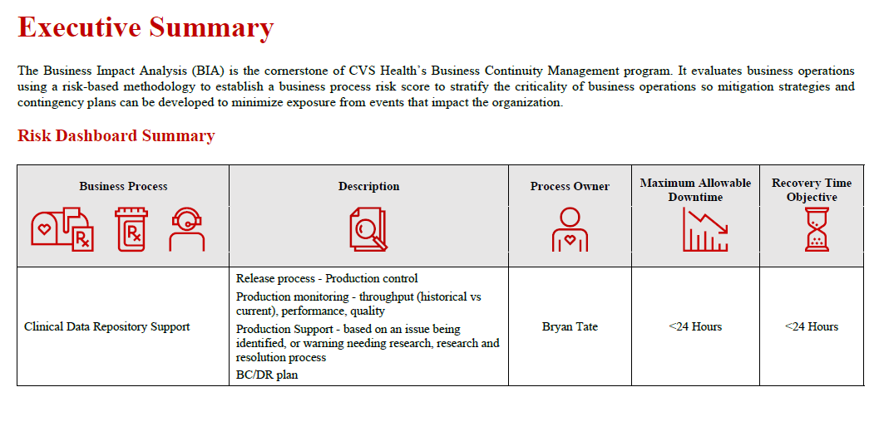

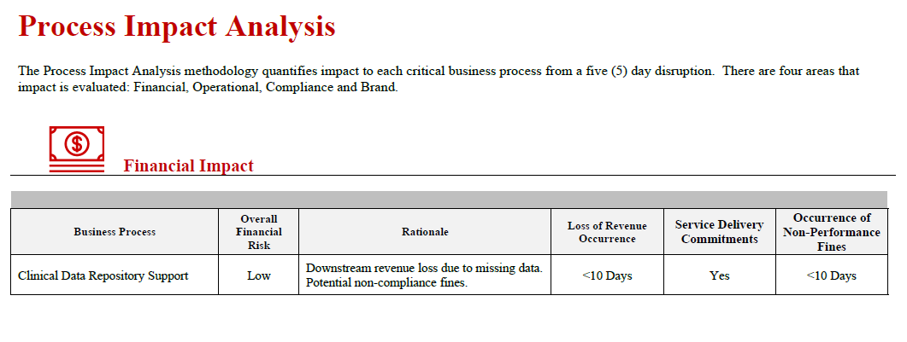

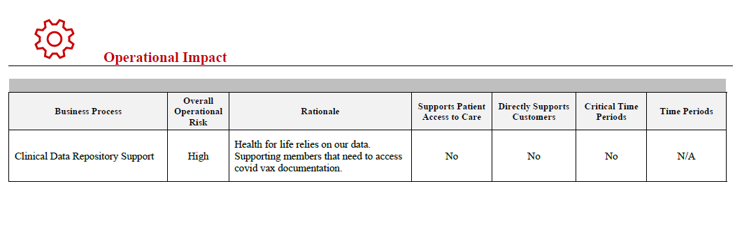

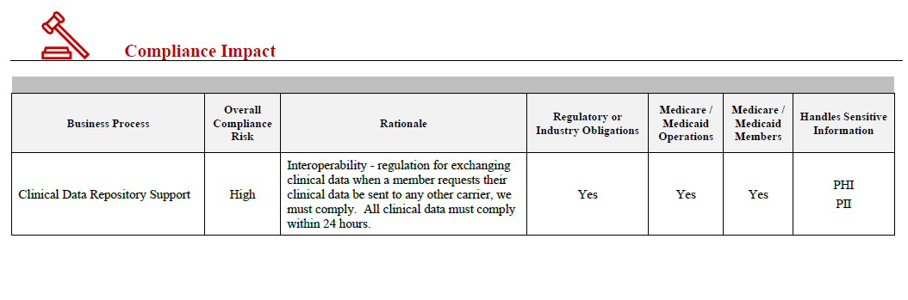

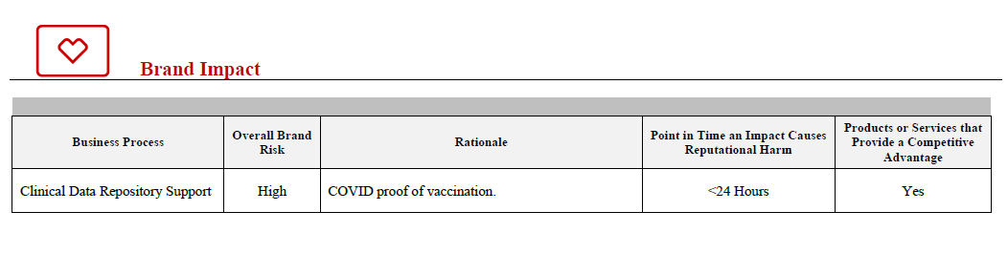

The application that supports CDR’s Critical Business Operations is GCP (Google Cloud). *See evidence below:*

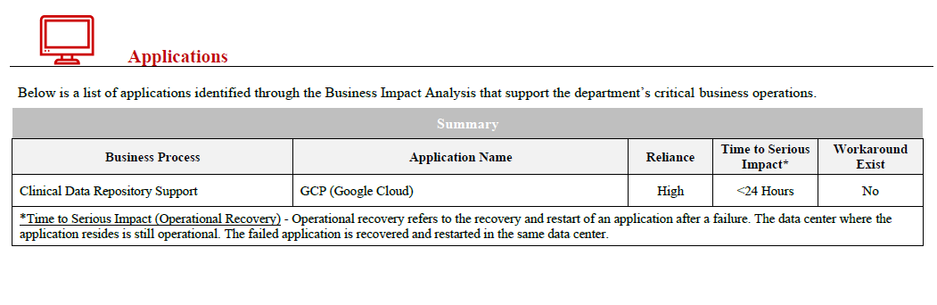

Link to full document: [Clinical Data Repository Support BIA](https://cvshealth.auditboardapp.com/download?file_id=155011&name=Clincal%20Data%20Repository%20Support%20BIA.pdf)